2020

Intercultural Cities –Annual report

Table of content
Foreword 2
Introduction 3
Major events in 2020 5
➢ Online meeting on “Covid-19: Challenges and opportunities for intercultural local authorities”, 23 April 2020 5
➢ Webinar on “Gentrification and interaction in the public space”, 11 June 2020 6
➢ Joint ICC/UNHCR webinar on “Creating Inclusive cities: everyone can make a difference”, 18 June 2020 6
➢ Webinar on “Instruments and tools to fight systemic racism”, 7 July 2020 7
➢ Webinar on “Preventing the potential discriminatory effects of the use of artificial intelligence in local services”, 21st September 2020 7
➢ Webinar on “Systemic Discrimination - Local Authorities’ Actions to Identify and Prevent”, 22 October 2020 8
➢ Workshop on Community Sponsorship, 5 November 2020 9
➢ Inspirational session on Creative bureaucracy, 3 November 2020 9
➢ Annual meeting of ICC coordinators, 3-5 November 2020 9
Main Regional and Local Events 10
➢ Kick-off of the project “European Pact for Integration”, 4-5 February, Cluj-Napoca (Romania) 10
➢ Intercultural Integration Academy in Morocco, 18-19 February 2020, Marrakech, Morocco 10
➢ Intercultural Regions, 23 March, 29 June, and 25 November 2020 11
➢ Other local activities 12
➢ ICC experts’ visits 14
The Anti-Rumours methodology 14
➢ 5th Anti-Rumours Youth Summit, 2-4 September 2020 14
➢ Anti-rumours Manual for the school environment 14
New Tools and Methodologies 15
➢ Intercultural citizenship test 15
➢ Working Group on intercultural communication and alternative narratives 15
➢ Social trust barometer 15
Strategic Development 16
National networks 16
Visibility and awareness 17
Appendix I - Expenditure 19
Appendix II – Main documents 19

Foreword
The year that just passed has left no-one indifferent. Extreme climate events multiplied in several countries with devastating effects on both people and their natural heritage; the political landscape in many democracies saw an exacerbation of violent or hate speech, extremism, radicalisation of identity discourse and divisive narratives. Twenty-twenty was also the year of the “Black Lives matter” movement which, born in the USA, shed a much-needed light on systemic racism, discrimination, and sometimes police abuse against minority groups also in European countries.
But first and foremost, twenty-twenty confronted all of us to a World pandemic that showed how fragile humanity is in the face of unexpected crisis. While at the very beginning of the sanitary emergency people felt strong solidarity to each other, being unitedly confronted to disorientation, uncertainty and powerlessness, the length of the crises is showing differences in impact depending on countries’ wealth and resources. The same applies to communities worldwide, with serious threats to equality due to an increase in social inequalities. People, groups and territories which were already vulnerable before Covid-19 crisis are seeing their socio-economic situation worsening. Besides, not all citizens have had access to clear, transparent and understandable information. A more fragmented and segregated society is unfortunately a realistic scenario unless medium- and long-term strategies are put in place already now to map and address the specific challenges of the most vulnerable groups and individuals, and processes that involve the target groups in the preparation of the responses are promptly launched.
The Covid-19 emergency is also posing threats to diversity and interaction, the other two pillars of the intercultural integration approach. During the past months some countries have been witnessing public statements against certain nationalities and or hate speech, racial profiling to control quarantine and lockdown, increased risk of discriminatory actions by some police officers, increased risk of gender-based or homo-bi-transphobic violence in confinement.
In addition, cities across the world have always been melting pots of cultures, ideas and experiences. Offering everything from loud marketplaces to silent parks, our cities are the homes of sensations allowing us to experience new sounds, sights and smells every day. As the pandemic struck, many of our streets, markets, schools, theatres, cinemas and parks feel silent…
Yet, confinement and other restrictions have also triggered strong solidarity between neighbours regardless from nationality or residence permits, intergenerational support, youth engagement to be part of the solution, strengthening of social relations through digital tools, creativity, simplification of the administrative machines and their bureaucracy, and a strong resilience of human beings facing extreme situations.
In most cases, cities have been able to engineer into a sustainable frame the solidarity that sprang spontaneously. Together, we adapted to unprecedented constraints, we kept up our values, our ideals, our energy, and our enthusiasm towards promoting interculturalism and inclusion. Together, we are trying to find the way to make the best possible use of the lessons learned from this difficult situation, and to apprehend forced change as an opportunity for it to be productive.
For all this, the ICC team wish to warmly thank all its members and to express deep admiration for their work.

Introduction

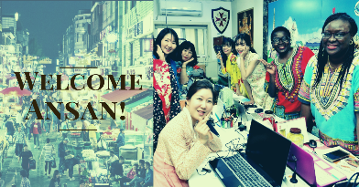 | 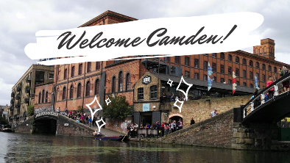
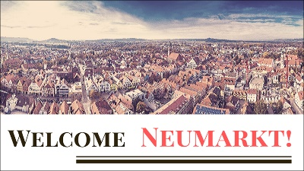 | 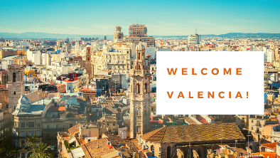
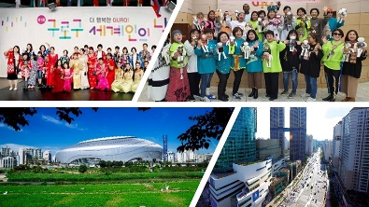 | 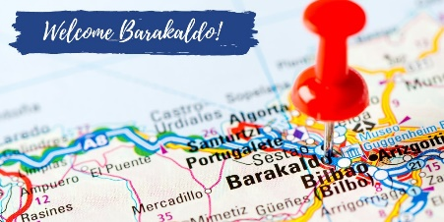
INTERCULTURAL CITIES (ICC) is a capacity-building and policy development programme that supports local authorities worldwide in designing, implementing and evaluating inclusive integration strategies built on a diversity management model called “intercultural integration”.
Intercultural integration is a policy framework for achieving inclusion, equality, community and societal cohesion, and prosperous development in diverse societies.

The cornerstone of the Intercultural Cities policy paradigm is the concept of “Diversity Advantage”, i.e. the idea that diversity can be an asset for communities - in particular in urban environments - if managed in a positive and competent way. Integration and inclusion policies are therefore devised from the perspective of people’s talents and potential, rather than focussing only on just satisfying basic needs. The underlying principles of intercultural integration take inclusive integration beyond anti-discrimination legislation and thus require active intervention by public authorities, especially at the local level.
Tested with cities and local authorities, the intercultural integration policy model has been endorsed – in 2015 - by the Council of Europe Committee of Ministers through the adoption of a specific Recommendation addressed to the 47 Member States. The recommendation recognises the ICC model as an effective policy approach to amplifying and managing as a resource the socio-economic benefits that diversity brings to European societies.
The Intercultural Cities’ programme offers a comprehensive methodology for city leaders and a range of analytical and assessment tools, including the Intercultural Cities INDEX. Completed by 116 cities and towns across 36 countries, the ICC Index assesses to what extent local authorities implement interculturalism, and is a reliable tool also for improving local policies and raising the national debate.
In 2020 membership raised up to 141, counting six new cities, namely: Ansan and Guro (South Korea), Camden (UK), Neumarkt (Germany), Valencia and Barakaldo (Spain). In addition, membership processes were initiated in seven other cities. New members mean more richness and more good practices to share, but also entail a need to adapt services and tools to new contexts and to an ever-increasing size of the ICC network. In 2020, particular attention was paid to providing more tailor-made services.
Among the most relevant:

- A Welcome pack initially conceived for new cities, which has become a useful tool for all the members. It contains practical documents for a quick dive into the ICC programme, including the Mission description of ICC coordinators; a brief for politicians; a Glossary; and a resource pack referencing the main ICC documents and resources.

- A brand pack for a common identity, particularly when participating in joint campaigns. The tool is available in several languages, so as the ICC logo.

- New format for index reports: twelve cities completed for the first time or reviewed the ICC Index. These are: Ansan and Guro (South Korea), Bilbao (Spain), Kobe (Japan), Leeds (UK), Melitopol (Ukraine), Neumarkt (Germany), Reykjavik (Iceland), Rochester (USA), Salisbury (Australia), Trollhattan (Sweden). In 2020, Index reports were based on a new internal guide for index report writing which has allowed for a quality increase and better harmonisation.

- Thematic surveys to collect good practice examples: carried out to prepare the thematic webinars, these surveys – combined with the spontaneous reporting from member cities – allowed to collect and share 111 good practices, on top of the know-how developed to deal with the sanitary crisis.

- The ICC Index Charts: they allow for the graphical display of all cities’ index results in the database, with possibility of filtered search by size of the city/population, foreign-born/non-nationals, country, policy areas, core index / «advanced» index, and progress over time.

- Translation in Non-official languages: saving in travels allowed for translations of the most relevant ICC guidance in languages other than English and French, giving priority to the languages of the national networks.

Extensive changes were applied to working methods, largely due to the unprecedent situation brought forward by the pandemic. Some of those changes have however given positive results and will be sustained as far as possible in future. The most relevant are:

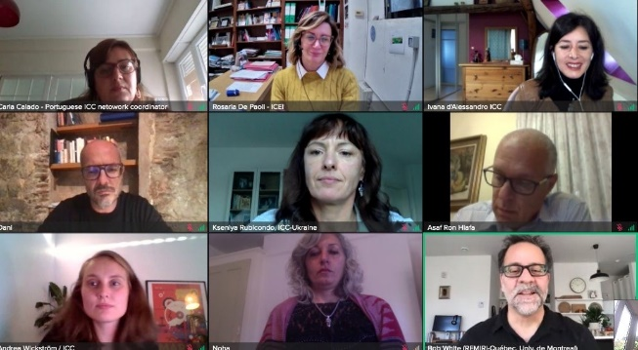
- Grants to support inter-city work (good for practice sharing, piloting, and networking);

- The meeting of Coordinators of ICC National networks for aligning national and international priorities;

- Webinars and online brainstorming meetings (allow for more regular contact; reach out to a larger audience and facilitate participation from non-European members; are organised over short and focussed sessions with less impact on the workload of ICC coordinators; infuse energy and enable the preparation of comprehensive policy packages).

Work started to produce - during the first half of 2021 - online courses on the Step by Step Guide to build an intercultural City; Artificial Intelligence and its discriminatory effects; and Intercultural communication.

Major events in 2020

Online meeting on “Covid-19: Challenges and opportunities for intercultural local authorities”, 23 April 2020
The ongoing global Covid-19 pandemic has had a large impact not only for all the member cities of the international network, but also for the work of the Programme. The situation has brought forward new ways of working, including webinars and online brainstorming meetings, as well as new thematic initiatives. The challenges brought forward by the sanitary crisis have taken a strong place in the political agenda of interculturally committed local authorities. From the perspective of local authorities acting interculturally in diverse societies, the safety measures imposed by the spread of Covid19 virus and disease pose emergency challenges linked to access to health care and related information; keeping contact, interaction and community work alive; countering discrimination, prejudice and hate speech, to quote only some.
Besides, a long-term approach to the challenges that may arise from the present situation after the Covid19 crises unavoidably brings in other dimensions focussing notably on human rights, equality and diversity, social inclusion and poverty. These are challenges that interculturalism may help to address in conjunction with legal standards and other settings, but they require preparatory actions already now, to foster community cohesion and sense of belonging despite social distancing.
These recent months have been marked by difficulties and distress for some, but also by creativity and resilience that have helped both the citizens and their local authorities to adapt relatively fast to a new setting. Some of the measures so far adopted have shown unprecedented courage on matters where advancement was not easy before. This is the case of measures such as the temporary regularisation of migrants to ensure they benefit from free health care; the allocation of work permits and unemployment allowances to migrants working in the agriculture; the building of hosting facilities for homeless people including migrants; the public recognition of the solidarity effort showed by the migrant communities who fundraised for the host health systems, and many more.
The Brainstorming meeting on “Covid-19: challenges and opportunities for intercultural local authorities” provided the occasion of a timely discussion on these issues; it was the first occasion for ICC coordinators to virtually meet and assist each other with innovative materials, approaches and know-how. It was also a great opportunity for making good use of the ICC as a network covering the five continents.
- Meeting report
- Covid-19 Special page: Policy Solutions
- The Anti-discrimination, Diversity and Inclusion dimensions of the response to Covid-19: Introductory Note prepared by the Secretariat of the Steering Committee on Anti-discrimination, Diversity and Inclusion (CDADI)

Webinar on “Gentrification and interaction in the public space”, 11 June 2020
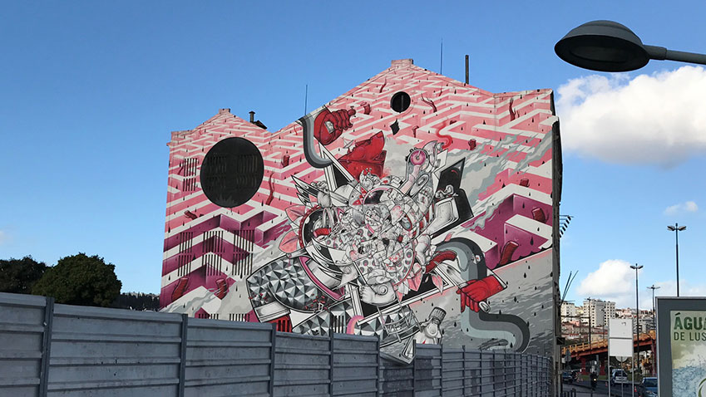
Gentrification is a process through which lower income residents are displaced from the neighbourhood due to an influx of new residents, resulting in a change of character of the neighbourhood. Therefore, gentrification has two key features: displacement, both physical and symbolic and change in social and urban character.
From an intercultural perspective, focus lies on the key principles of equality, diversity advantage, and interaction. In the intercultural city this is reflected through policies aiming to create equal access to all to the neighbourhoods by offering for example affordable housing. Diversity is strengthened through policies for social mixing and supporting the cultural, economic and social fabric of neighbourhoods by promoting a pluralistic and inclusive identity. This also underlines positive interactions, aiming to create positive neighbourhoods with spaces to interact and live in.
The webinar presented an ICC study on gentrification, prepared during the spring with ICC experts Mela Social Enterprise and thanks to the contribution of member cities that participated in a dedicated survey. The webinar took ICC study as a starting point, and gave further attention to the exceptional circumstances that Covid-19 has created in the public space, providing answers to questions on how to increase interaction in the time of social and physical distancing.
After the webinar, a thematic page on Gentrification has been built to collect all material produced on the topic, including an ICC policy brief.

Joint ICC/UNHCR webinar on “Creating Inclusive cities: everyone can make a difference”, 18 June 2020
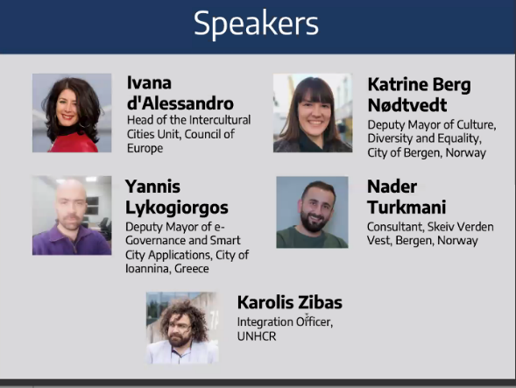
More than 61 per cent of the world’s refugees and 80 per cent of internally displaced people live in urban areas. The role of towns, cities, counties and provinces in creating inclusive communities and promoting hope has never been as important. They offer safety and shelter and can enable access to local services, education and job opportunities. The Global Compact on Refugees aims to implement a more holistic approach in responding to refugee displacement and recognizes the important role that local authorities play as first responders to large-scale refugee situations.
On the occasion of the World Refugee Day, the Intercultural Cities Programme and the UNCHR invited practitioners from across the world to a webinar on “Creating Inclusive cities: everyone can make a difference”. The webinar highlighted the key role of local authorities (Bergen in Norway, and Ioannina in Greece) in making their cities spaces where everyone can live in safety, become self-reliant, and contribute to and participate in their local community. It also offered the perspective of a citizen who benefitted from the protection framework offered by the UNCHR, and the intercultural policies put in place by the city of Bergen (Norway) for refugee inclusion.
The recording of the webinar is available on YouTube.

Webinar on “Instruments and tools to fight systemic racism”, 7 July 2020
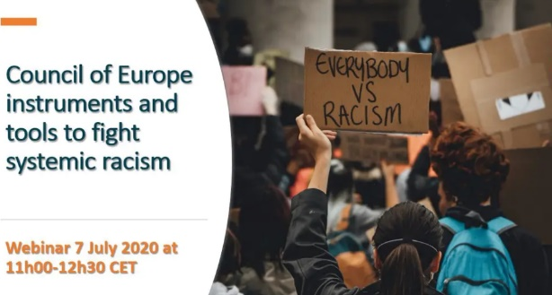
On 7 July, the Anti-Discrimination Department of the Council of Europe held a webinar on “From challenges to solutions: instruments and tools to fight systemic racism”.
In the aftermath of the killing of George Floyd by a police officer in the USA, large and durable protests against racially motivated discrimination, violence and police brutality have flared up across the globe. These protests have raised awareness among minorities and majorities alike of the scale of these phenomena, which are incompatible with the human rights values of the Council of Europe and have created a sense of urgency to act.
The webinar explored successful strategies and inspiring actions, from both States and local authorities, to address systemic and institutional racism, and examined the effectiveness of Council of Europe tools and actions. The speakers emphasised the need to further strengthen their application in member states and welcomed the recent ECRI statement against racial profiling in policing and calling for a systemic response to address racism in all areas.
The panel also underlined the importance of education to combat deeply engrained racism and that training of police is key for them to become part of the solution.
The recording of the Webinar is available online.

Webinar on “Preventing the potential discriminatory effects of the use of artificial intelligence in local services”, 21st September 2020
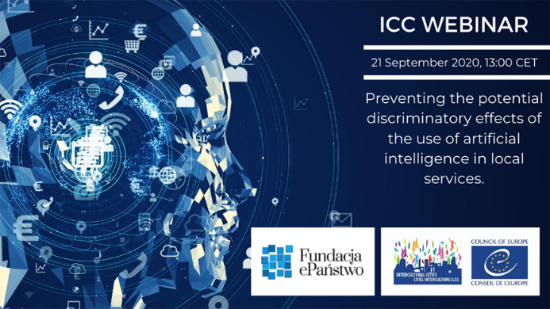
Municipalities provide a wide range of public services to their citizens and increasingly this is supported by technologies including Automated Decision Making (ADM) tools and Artificial Intelligence (AI) solutions. The deployment of IT tools in public services has brought new challenges and potential risks of bias, prejudice towards certain categories of citizens, and discrimination. Such risks were, for example, detected in the Dutch SyRI system used by national and local authorities to detect housing or social security fraud, smart water meters in several cities in Europe or AI applications used in staff recruitment.
Intercultural cities develop policies and expertise in social inclusion and equality, prevention of discrimination, and raising awareness around important societal challenges. It is useful for decision-makers to also understand the potential biases and risks of AI, and learn about ways of mitigating such risks. The experience of advanced cities could help build trustworthy and ethical AI.
The Intercultural Cities programme and ePaństwo Foundation invited ICC member cities to take part in a 2.5-hour webinar about the challenges Artificial Intelligence and Algorithmic Decision-making present for local authorities, in particular in relation to anti-discrimination, inclusion, and the fight against hate speech. As a follow-up, Intercultural Cities and ePaństwo Foundation have produced a Policy Brief to give policy guidance on the matter. An online training will be released in 2021.
- Policy brief
- Concept note
- Video clip

Webinar on “Systemic Discrimination - Local Authorities’ Actions to Identify and Prevent”, 22 October 2020
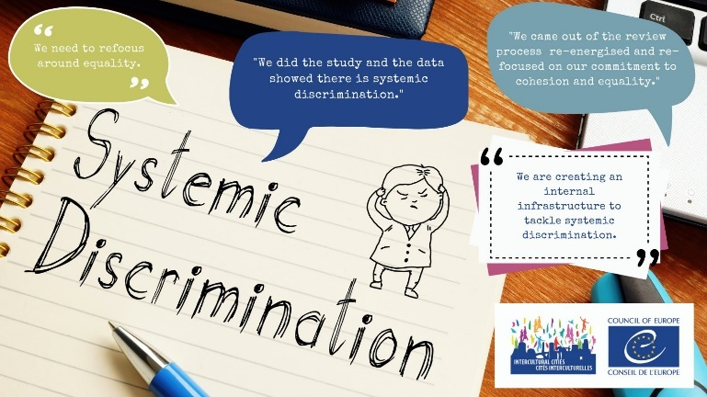
Systemic discrimination involves the procedures, routines and organisational culture of any organisation that, often without intent, contribute to less favourable outcomes for minority groups than for the majority of the population, from the organisation’s policies, programmes, employment, and services.
Systemic discrimination comes under a range of titles in the literature including “structural discrimination”; “institutional discrimination”; and “systematic discrimination”. It is not specifically defined in international or European legislation and it cannot be tackled on a once-off basis: it requires sustained attention from and initiative by organisations. Because identifying and preventing systemic discrimination in their own organisation and beyond is key for the intercultural city, the ICC programme launched a Study to identify interlinked strands of activity, evident in the practice of the cities, that are necessary to effectively address systemic discrimination. The Study and Policy brief were presented in a webinar that analysed systemic discrimination and gave insights on how to create the conditions within an organisation to tackle it. Showcasing the practices of a few successful cities, the webinar also addressed how to render systemic discrimination visible, how to develop systemic remedies to what is a systemic problem, and ultimately how to enable a coherent response to systemic discrimination across all sectors.
A thematic webpage collects the policy package so developed, including a video tutorial, a Policy brief, and the Research study.

Workshop on Community Sponsorship, 5 November 2020
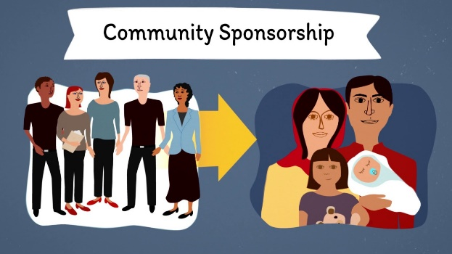
This practical workshop aimed at familiarising ICC members with Community sponsorship, a model that provides opportunities for making cities more welcoming for those who arrive often in distress, engage community resources by involving the citizenry in the welcoming process, and make refugee welcoming bureaucracy more creative.
The Global Refugee Sponsorship Initiative (GRSI) promotes advocacy, and mainly works with assisting with the concrete implementation of community sponsorship programmes across the globe. They can for example provide dedicated staff to countries to build their programme and can also support countries who have already moved past implementation to help scale the programme and assess the policies implemented. The GRSI can also offer connections through their global network to share experiences. Interested cities can contact the ICC team for more information.

Inspirational session on Creative bureaucracy, 3 November 2020
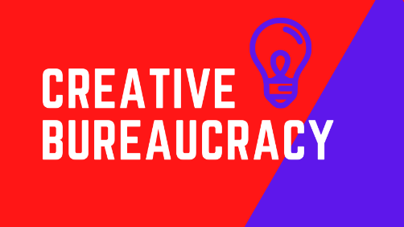
In line with its innovation mood, the ICC programme invited Charles Landry, President of Creative Bureaucracy, to present the creative bureaucracy philosophy. The inspiration of the Creative bureaucracy idea is to go against negative perception of public service as corporations, and respond to the decline of the public as a force for the common good, the rise of inextricably woven complex problems, a recognition that the solution is a collective endeavor between the different interest and components of a region or city.
The creative bureaucracy notion is framed within and emerges from the notion of the creative city; it focuses on how to find new innovative solutions to administrative problem-solving in the city by exhorting to create the conditions for people and their systems to be able to think, plan and act with imagination.
- ICC briefing paper by Charles Landry.

Annual meeting of ICC coordinators, 3-5 November 2020
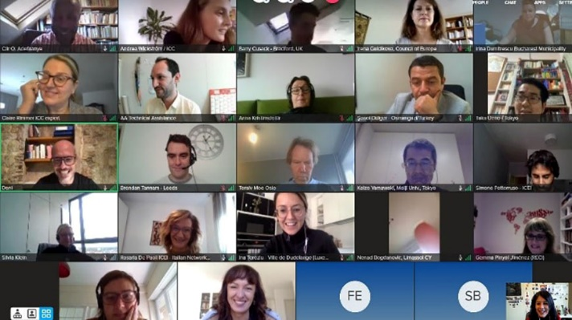
Sadly enough, also the ICC coordinators’ meeting had to take place online. This is the annual gathering of coordinators of ICC international members to take stock of achievements, putting forward and discussing new challenges ahead, and preparing the next programme of work. Among the highlights of the 2020 agenda there were the public presentation of the Intercultural Citizenship test, break-out groups to discuss a set of proposed indicators to evaluate the degree of interculturality of projects’ proposals, and a brainstorming session on challenges related to building societies based on real equality, diversity advantage and positive interaction in the post-Covid19 era. In addition, a half day high level session was devoted to exchanging with member cities’ Directors and Mayors/Deputy Mayors.
- Meeting report

Main Regional and Local Events

Kick-off of the project “European Pact for Integration”, 4-5 February, Cluj-Napoca (Romania)
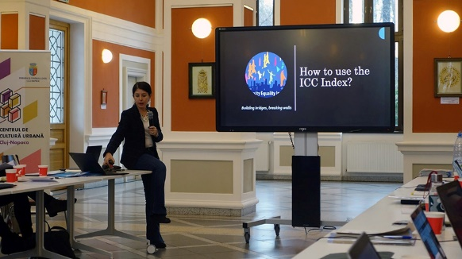
The European Pact for Integration (EPI) is a project that brings together local and regional bodies from Estonia, Germany, Greece, Italy, Latvia, Poland, Romania, Spain and Sweden, to develop successful intercultural integration strategies through peer mentoring and knowledge exchange. The project is funded by the European Union through AMIF grants. The Association of Intercultural Cities that runs the Spanish Network of Intercultural Cities is part of the consortium that lead the project while the ICC programme is providing specific expertise via its Intercultural Cities Index. Participant cities include also three ICC members: Cartagena (Spain), Lublin (Poland), and Ravenna (Italy).
The first phase of the project consists of assessing participants needs through an ICC Index review adapted to the EPI context. The results of the review will give partners a better understanding of the local context and will lay the base for further community tailored solutions. Next steps will involve 1) participatory processes for strategy co-design and co-implementation through Policy Design round tables, 2) public awareness about the new integration policies through official launching events, awareness raising events, and the setting-up of integration pacts in each partner city. This was the last event held in person before the pandemic.

Intercultural Integration Academy in Morocco, 18-19 February 2020, Marrakech, Morocco
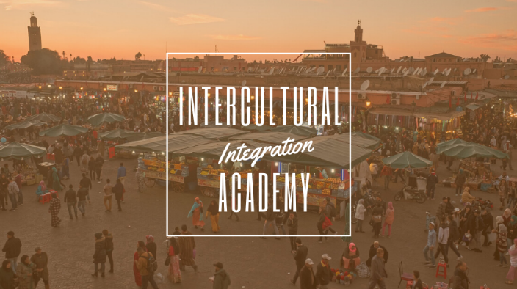
This Intercultural Integration Academy was organised in the framework of the European Union/Council of Europe joint programme “Ensuring Sustainable Democratic Governance and Human Rights in the Southern Mediterranean” (South Programme III), co-funded by the two organisations and implemented by the latter. The South programme aims at helping to build a common democratic space based on shared values, legal safeguards, effective institutions and active networks across the Mediterranean. The intercultural academies are a concept developed by the ICC programme to give participants a broad introduction of interculturalism on a wide range of topics presented by ICC experts. In Marrakech, the academy focused on policy-making and strategies for the intercultural city as well as the anti-rumours methodology. The academies are a good entry to the ICC and the tools available, as well as for the cities to meet and exchange experiences.
While the ICC already has a national network in Morocco, participants from Tunisia, Jordan and Palestine met the ICC for the first time. The Academy also introduced the national networks and benefits of the Programme to the member cities.
- Report of the Intercultural integration Academy in Marrakech

Intercultural Regions, 23 March, 29 June, and 25 November 2020
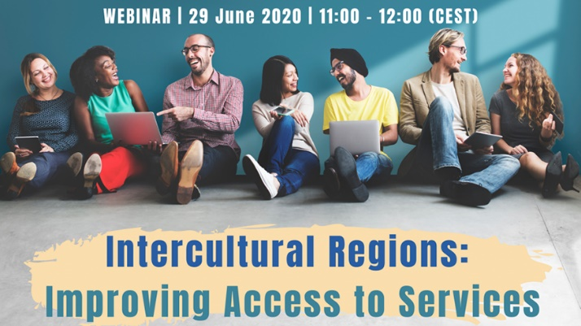
On 23 March the ICC programme and the Intercultural Regions’ network had their first meeting online. Participants included representatives of nine regions from Sweden, Italy, Norway, Spain, and Romania, as well as representatives of the Assembly of European Regions and the ICC Team.
The meeting identified the fields in which the ICC programme and tools can provide tailored made assistance to address the needs of intercultural regions. These are namely the following:
  - Awareness raising and capacity building on intercultural competence for staff and public officials;
  - Empowering community participation at regional level;
  - Intercultural strategies building and development.
Besides, participants got acquainted of the latest progress within an EU funded project that consists in the mapping of Regions’ needs with the view to prepare an Intercultural Regions Index, based on MIPEX and ICC Index. Such an Index would allow regions to measure their progress towards becoming more intercultural. Following that meeting, another webinar took place in June to discuss ways to improve access to services for diverse residents. The webinar was organised by the Assembly of European Regions, The Council of Europe/Intercultural Cities and IOM and was an opportunity for structured and meaningful mutual learning on inclusive integration, for the members of the Intercultural Regions Network. Finally, in November work with the Intercultural Regions continued with the view of defining capacity-building actions (such as the planned Intercultural Regions Academy provisionally scheduled to take place in June 2021 in Strasbourg), a strategy for raising political support for intercultural policies across Europe and with European institutions, and a project proposal which would help resource the development of an Intercultural regions index and regional intercultural strategies.

Other local activities
Working online paradoxically facilitated exchanges and networking among member cities, and gave the opportunity to the ICC programme for providing tailor-made support to individual cities or small groups of cities.

In this line, specific ICC grants supported inter-city work and have resulted into a number of successful projects that contributed to practice sharing and piloting new methodologies:

- Limassol (Cyprus) and Ioannina (Greece) engaged in the project “Intercultural Twinning: Cultural Diversity for Inclusive Growth.” The two cities joined forces to promote cultural diversity as an asset for inclusive growth in post-pandemic era. They carried out a series of information and public consultation activities on this topic, culminating with the adoption of Joint Declaration on “Cultural Diversity as an advantage for economic development and social cohesion” which will guide future work.

- Melitopol (Ukraine) and Ballarat (Australia) implemented “Introducing and Engaging Diversity Globally“, a project that finally involved also the cities of Lutsk, Odessa, Pavlograd, Vinnytsia, and Sumy (Ukraine), Adelaida, Bacchus-Marsh, Maribyrnong, Melbourne and Melton (Australia), and Hamamatsu (Japan). The project aimed to contribute to the advancement of intercultural competence skills of city administrators, police, media, minority and religious groups representatives, internally displaced persons and other city residents by offering a series of workshops conducted by local trainers who were formed through a series of online ICC competence. An impact evaluation study has also been conducted.

- Reggio Emilia and Novellara (Italy) worked on “Valuing religious communities as key actors of social cohesion” and released a multilingual Handbook to support public administrations in managing increasingly complex local contexts, where religious pluralism is one of the fundamental aspects for the promotion of intercultural dialogue.

- Bilbao, Castellò de la Plana, Donostia/San Sebastiàn, and the Island of Tenerife (Spain) successfully concluded a project on “Developing the intercultural skills of public administration”, with an innovative specific focus public procurement processes and public aid in general. The project consisted in needs assessment, development of training modules and materials, and the production of a multilingual Guide and a video-tutorial collecting inspiring local experiences and pointing to the key elements for success.

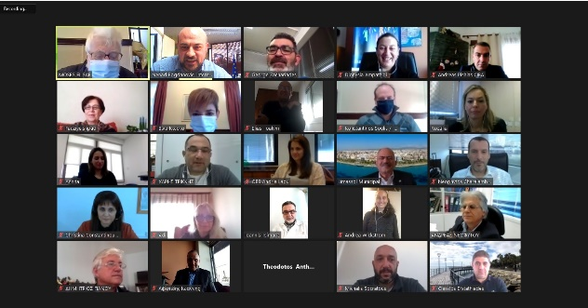 | 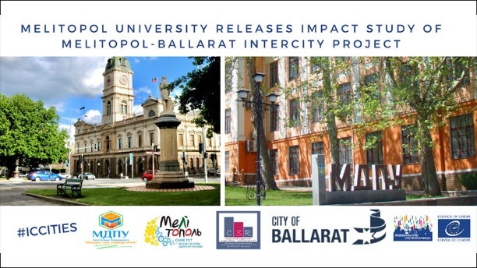
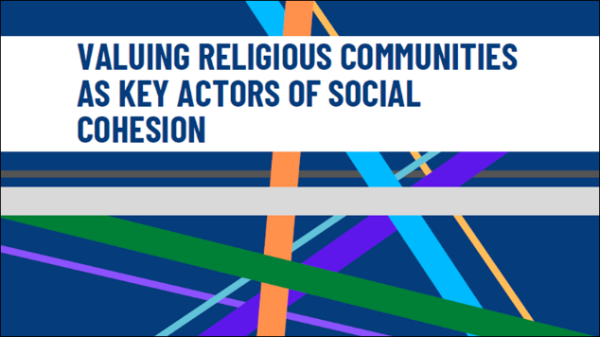 | 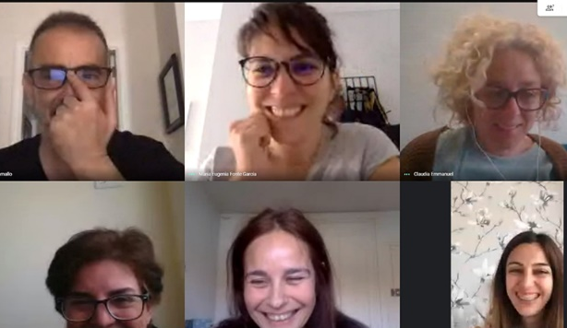

In addition, the ICC programme provided specific expertise and support to the following activities:
- Neuchâtel Canton (Switzerland) received support for research and preparatory work towards the creation of a board game on diversity and non-discrimination. The game will be produced next year in the frame of the thirty anniversary of the Canton’s integration policy. It will delivered in a format that can be transferable to other ICC members.

- Limassol (Cyprus) was accompanied in the first steps towards the implementation of a tailor-made an anti-rumours strategy to be carried out in 2021 as part of its intercultural strategy.

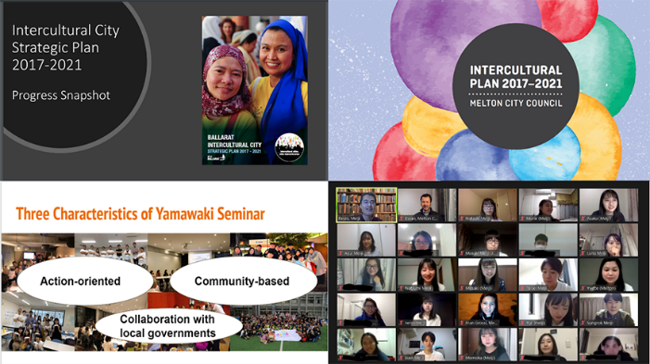
- Australia and Japan: city officials and students from Ballarat and Melton (Australia) participated in online exchange sessions with students from Meiji University (Tokyo) who study intercultural issues. The webinars also involved observers from various cities, including Hamamatsu, Kobe, and Maribyrnong, as well as Japanese semi-governmental organisations, the Japan Foundation and the Council of Local Authorities for International Relations, both of which have supported the exchange between Japanese cities and the member cities of the ICC network in Europe and beyond, together with the Council of Europe.

- Kobe (Japan): the Kobe City Government (Japan) held a study meeting on 1 September 2020 to prepare its membership to the ICC programme. The meeting gathered representatives from Kobe, Hyogo Prefecture, Hamamatsu, Kobe International Center for Cooperation and Communication, Hyogo International Association, NPO Kobe Foreigners Friendship Center, NPO Multilingual Center FACIL, NPO Oneself, Kobe UNESCO Association and the ICC team with a few ICC experts.

- Malta: the ICC further supported expert work with the national government of Malta to include the intercultural perspective into the to-be-adopted National plan against racism and xenophobia.

ICC experts’ visits
Expert visits are organised to assess the level of progress of member cities in the implementation of their intercultural strategies, and to confirm Index results. These are usually on-the-spot visits; however, the pandemic prevented the ICC team and experts to travel. Yet, two courageous cities decided not to miss the opportunity of an exchange and agreed to have their visits through virtual participation under an adapted format. These cities are Rochester (Minnesota, USA) and Loures (Portugal). The intercultural profiles produced following the virtual visits have been published online.

The Anti-Rumours methodology
The “Anti-rumours methodology” has been developed to counter diversity-related prejudices and rumours that hamper positive interaction lay the foundations of discriminatory and racists attitudes. Standardised through the publication of a Handbook translated in several languages, the methodology is being now applied by a growing number of cities and it is being complemented by a number of practical tools for its implementation.

5th Anti-Rumours Youth Summit, 2-4 September 2020
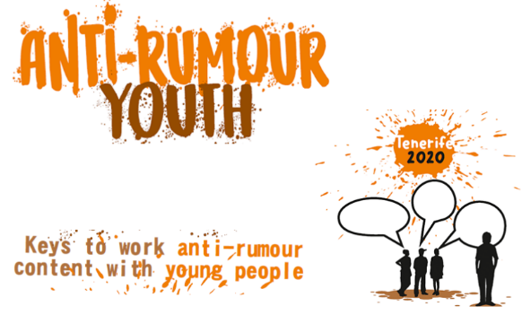
For the fifth time the ICC programme supported the organisation of the Anti-Rumours Youth Summit which, in 2020, was organised and hosted by Tenerife (Spain). The 2020 Anti-Rumours Youth Summit gathered young people from Cartagena Libre de Rumores, Getxo Anti-Rumours Gazteak, Stop Rumores Barakaldo and the Tenerife children’s participation group 'Amiguitos y Amiguitas'. It had a hybrid format combining an integrated session in the La Esperanza Youth Camp (Tenerife) and online sessions for youth from all over Spain. The Summit engaged anti-rumours youth in several activities including the drafting of an 'Anti-rumours Declaration', the pilot test of the "Escape Rumours" board game, the participatory design of the "Anti-Rumours Museum", and the workshop on "Social networks and hoaxes: how to generate mechanisms to counteract them".
The Summit also launched work that led to the preparation and launch of the Handbook for Anti-rumours work with young people.

Anti-rumours Manual for the school environment
Answering to the need to develop anti-rumours tailored tools for schools’ use, the RECI and the Italian Network Città del Dialogo have worked on a manual that aims at promoting critical thinking in young people and educate them on how to dismantle rumours and stereotypes that hinder peaceful and productive coexistence in diverse societies. The Manual further builds on the results of the Io Rispetto (I respect) project, run by Città del Dialogo. Both resources are available in the respective national languages as well as in English.

In addition, the RECI developed a Step-by-step guide to conduct and Anti-rumours diagnosis which complements the resources available on the ICC Anti-rumours page.

New Tools and Methodologies

Intercultural citizenship test
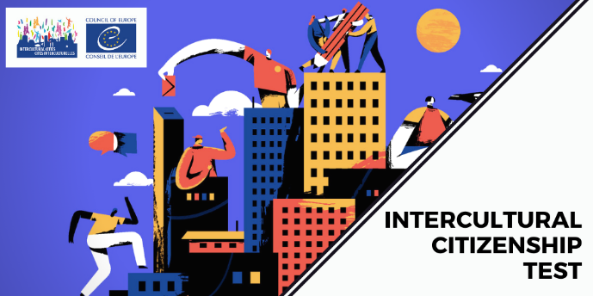
In 2020 the ICC programme finalised and launched the Intercultural Citizenship Test – a tool for each and everyone to find out more about what it means to be an intercultural citizen. The test is a powerful tool for building intercultural understanding of active citizenship, suitable for multiple uses in multiple contexts. It can be taken online on the ICC web, individually or in small groups, and is a quick and inspirational way to learn more about interculturalism. It also comes with a facilitator guide for small group discussions which offers topics and ideas for further exploration and learning. The test is already available in several languages and more translations are being carried out, some of which thanks to the contribution of member cities.

Working Group on intercultural communication and alternative narratives
A working group made up of four ICC experts and the ICC team worked towards the preparation of an ICC Academy on intercultural communication and alternative narratives. This will consist of a full training course specifically addressing intercultural communication needs. Building on past training experiences with training on intercultural communication, and on the work of the national networks – RECI in particular – on alternative narratives and positive intercultural communication, the academy will focus on how to embed intercultural principles in local authorities’ public communication. It will target both cities’ communication officers and ICC coordinators and be suitable for both in-person course, as well as an online course accessible to member cities only.

Social trust barometer
This is a pilot project trying to answer to the need of measuring the impact of intercultural actions in a smart, compelling, efficient and cost-effective way. Social trust would indeed be an excellent criterion to bring evidence of the efficiency of intercultural measures; yet, it is also something difficult to assess. The social trust barometer will work on connecting three dimensions: big data including social media data, social sensing, and observing social interactions at a micro level, mostly analysed by artificial intelligence. Botkyrka (Sweden) volunteered to carry out a pilot test which has already delivered very promising results. The next step in 2021 will be to develop a user-friendly app and to carry out tests at a larger scale.

Strategic Development
Since 2017 the ICC programme multiplied efforts to promote dialogue and co-operation among local, regional and national authorities in the field of migrant integration. Four “Policy Labs on inclusive integration” were carried out with the view of enable transfer of innovation, policy co-ordination and consistency across the different levels of governance. This work culminated in a landmark decision taken by the Council of Europe Committee of Ministers in December 2019, through the setting-up of an intergovernmental working group on intercultural integration. Called GT-ADI-INT, this is the first body of this kind to have a multi-level nature, gathering twenty elected officials representing ten Council of Europe (CoE) member states and ten cities that are member of the Intercultural Cities international network. The working group operates under the Steering Committee on Anti-Discrimination, Diversity and Inclusion (CDADI) and is further open to any other CoE member states, as well as to a number of observers. Its main goal is to assist CDADI in steering Council of Europe’s intergovernmental work “to promote equality for all and build more inclusive societies”, with a particular focus on intercultural integration and positive diversity management policies.
The Group held two meetings in 2020 and: i) promoted exchanges among officials from different levels of governments; ii) collected and assessed existing policy practices; iii) developed draft Guidelines and a Model policy framework for an intercultural integration strategy at the national level; iv) advanced work towards the preparation of a draft Recommendation on multi-level governance of intercultural integration of migrants. The Working Group grounded its programme of work on existing CoE standards as well as outstanding practice from local authorities.
The setting up of this working group is a major step towards transferring the ICC policy model to the national level, thus increasing local authorities’ ability to work in cooperation with their national counterparts in a field where competencies are interlinked.

National networks
The ICC programme has, for many years, supported the creation and development of regional and national networks. These are often at the forefront of pilot initiatives and at the origin of new ICC methodologies which benefit the whole international network. The latest developments concern the following:

- Australasian Network: the expansion of the model to South Korea and the increased commitment in Australia and Japan have pushed concerned cities to organise themselves into a regional network. At the moment they are working at a common intercultural strategy and at the setting up of a governance model for their network. The members have also been very active individually, with a number of awareness raising events and training organised.

- Città del Dialogo: a very prolific year with three main highlights: i) the launch of the ITACA (Italian Cities Against Discrimination) project, ii) a number of significant policy changes in a few member cities; iii) a social media communication campaign to building intercultural understanding with the wider public.

- Norwegian and Nordic networks: active for a decade, the Norwegian network is more a forum for consultation and cooperation among Norwegian cities on policies and initiatives. Last year, the coordinator of Klaksvik (Faroe Islands) proposed to initiate an informal platform for cooperation among Nordic cities, so to expand the geographical scope. Despite the slow-down due to the Covid-19 crisis, efforts towards the setting up of a common mandate for the cities interested in this regional cooperation are continuing and will be pursued next year.

- RECI – Spanish network of Intercultural Cities: in 2020 the RECI has set up – for the first time – thematic working groups on: 1) intercultural competence (mapping needs, and devising resources to ensure training sessions, know-how sustainability, transversality of action, civil society participation); 2) welcome policies from an intercultural lens (putting intercultural principles at the core of the city policies); 3) intercultural narratives (work in progress towards a practical guide to crystallise the extensive theoretical body of knowledge into practical tips, best practices and strategies to involve politicians and civil servants).

- RPCI – Portuguese network of Intercultural Cities: in 2020 RPCI worked on addressing the gaps identified by the members in previous years. They produced an online course on the ICC Step-by-step manual as a way to promote intercultural competence and know-how among staff. They also launched “Cities of welcome”, a project to increase RPCI members’ capacity to interculturally welcome the new residents. For the latter, RPCI members consulted each other and aligned their migrant integration plans, assessed gaps and needs, and worked on i) finalising the welcoming app for migrants; ii) putting in place a database of events and campaigns, iii) and developing a customisable welcoming course for newcomers and other groups.

- ICC-UA – Ukrainian network of Intercultural Cities: the national events initially scheduled to take place in 2020 have been postponed to next year due to Covid-19 emergency. Yet, the shift to online meetings provided new opportunities for the involvement of Ukrainian cities in the work of partners outside the country. Synergies have been built with other projects from the Council’s Anti-discrimination department, such as the one on the protection of national minorities in Ukraine, aimed at stabilising the dialogue between national minorities and regional administrations. Besides, Melitopol has involved all other member cities into a project on developing intercultural competence of public officials, which also involves cities in Australia.

- Québec – REMIRI: this is not yet an ICC network but an informal initiative of a number of Quebec cities backed by academia. Following the visit of the ICC team to Montreal last year, REMIRI cities are working on restructuring their network and mobilising the relevant administrations so that they can officially join the ICC programme.

Visibility and awareness

The ICC programme update its communication strategy every year. In 2020, a new brand pack has been produced for members to adopt a common identity while communicating nationally or internationally.
In the framework of its communication strategy, the ICC programme published a total of 111 news and 117 good practices from member cities, on top of the know-how developed to handle the Covid-19 emergency.
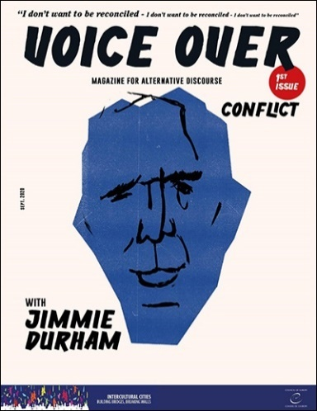
The ICC newsletter has been issued as scheduled, five times over the year (every two months except on summer break), and the ICC programme is also regularly featured in the bi-weekly newsletter of the Directorate General of Democracy.
Besides, ICC activities were portrayed six times on the Committee of Ministers “week in brief” information page, six times as highlights on Council of Europe main webpage, and regular contributions were made to the newsletters of the Council of Europe Special Representative for Migration. Moreover, ICC activities were mentioned at least nineteen times in local or national TVs and newspapers in Spain, USA, Italy, and Japan.

A novelty in 2020 has been the issue of Voice Over, a one-off magazine consisting of three special issues inviting renowned and provocative thinkers from the international sphere to address matters of concern for society. The magazine was the occasion to confront very diverse artists and share their perception of interculturalism, in a virtual dialogue with a few member cities. The first addressed the idea of conflict, the second one addressed the risks of artificial intelligence, while the third and last discussed the idea of borders.

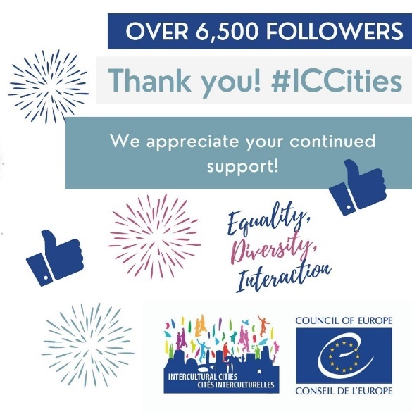
Regarding social media, the number of followers on Twitter and Facebook continued to increase, with respectively a total of 3.626 (+341) and 6.651 (+897) followers. The Facebook page now regularly displays guess games (Guess the city), fast facts (to counter mis-knowledge) and a Monday motivation to boost the week.

As for the ICC website, it got a 73% increase in visits and the Covid-19 resource page has been referenced by IOM, UN, the EU and the Congress of Local and Regional authorities.

In terms of publications this year was particularly productive, with numerous new tools listed in the Appendix to this report. Also, the use of gender-neutral French was sustained and the use of gender-neutral Spanish and Portuguese was introduced.

Finally, the ICC programme organised special publications for a few international days, including the International Day Against Racial Discrimination and the World Day on Cultural Diversity, and organised joint campaigns with its member cities on the occasion of the World Refugee Day and the International Migrants Day. Over 30 Mayors of around the World shared intercultural messages in support of welcoming Refugee people, while for the Migrants Day the voice was given to the proud residents of the intercultural cities. For the first time, both campaigns were echoed and relayed by CoE social media accounts and the CoE intranet and homepage displayed the banners created by the ICC programme for those occasions.

Appendix I - Expenditure
A total amount of € 436,642.14 has been spent on the implementation of the ICC programme. This amount represents operational expenditure (activities) and does not include staff and office costs. It will be adjusted after certification by the Council of Europe treasurer.

Appendix II – Main documents

ICC publications - 2020

Policy briefs
- Preventing the potential discriminatory effects of the use of artificial intelligence in local services (October 2020)
- Identifying and Preventing Systemic Discrimination at the Local Level (October 2020)
- Managing gentrification (June 2020) + Spanish version
- LGBTI Inclusion and Equality Initiatives for the Intercultural City (May 2020)

Welcome pack (available also in French, Spanish, Italian and Ukrainian)
- Mission description for ICC coordinators
- ICC background note for policy makers
- ICC Key terminology (glossary for practitioners)
- ICC Resource pack: most relevant ICC documents and resources condensed in a single page!
- ICC brochure
- ICC Info sheet

Publications, guidance and video tutorials
- The Creative Bureaucracy: What, why and how (November 2020)
- Intercultural Citizenship Test (+ Italian / + Ukrainian)
- Guide on Intercultural Competence (+ Spanish version) (November 2020)
- Intercultural competencies applied to the development of public administration projects: Guide (+ Spanish version), and video-tutorial (multilingual subtitles)
- Intercultural Competence Development: Introducing and Engaging Diversity Globally - Project Impact Analysis (December 2020)
- Identifying and Preventing Systemic Discrimination at the Local Level: Policy Study and video tutorial
- Handbook “Valuing religious communities as key actors of social cohesion” (2020) [+ Arabic version / + Italian version]
- Step-by-step guide to conduct and Anti-rumours diagnosis (December 2020)
- Guide “Anti-rumour youth: keys to work anti-rumours content with young people” (2020) + Spanish version
- An Antirumours’ Guide for the Educational Field (2020) + Italian version + Spanish version
- Managing Gentrification - Intercultural Cities Policy Study (May 2020)
- COVID-19: Challenges and opportunities for intercultural local authorities - Summary Report (+ Italian)
- How to fill in the Index? Video Tutorial
- ICC Index Charts
- ICC Brand pack
- Intercultural Cities: An Intercultural Dialogue as a tool for Social Cohesion (2020) [Turkish version]
- Survey on the implementation of the ICC programme and tools - January-February 2020

Documents relevant for the national networks

Italy (Città del dialogo)
- Città del Dialogo annual report 2020
- L’anti-rumours a scuola
- Pacchetto di benevenuto ICC
- La città interculturale passo a passo
- ICC Brand pack
- COVID-19: Sfide e opportunità per le autorità locali interculturali - Riunione online, 23 aprile 2020 - Rapporto di sintesi
- 10 criteri per la creazione di efficaci narrative alternative sulla diversità (2020)
- Città Interculturali - Manuale sulla polizia di prossimità (2020)
- Manuale per Valorizzare le comunità religiose come attori chiave della coesione sociale (2020)

Morocco (ICC-Maroc)
- Anti-rumours Manual: Arabic version

Spain (RECI)
- RECI - 20th Working session - Online – 10 November 2020 (Spanish version)
- RECI - 19th Working session - Online – 2 July 2020 (Spanish version)
- RECI - 18th Working session - Online – 2 April 2020
- Paquete de bienvenida ICC
- Competencias interculturales para cargos técnicos y políticos de la administración local (2020)
- Manual de competencias interculturales aplicadas al desarrollo de proyectos en la Administración Pública (2020)
- Repensar la Acogida desde la perspectiva intercultural (2020)
- Gestión de la gentrificación - Resumen de políticas (2020)
- COVID-19: DESAFÍOS Y OPORTUNIDADES PARA LAS AUTORIDADES LOCALES INTERCULTURALES - Reunión telemática, 23 de abril de 2020 - Informe resumido
- Guía Antirumores en el ámbito educativo, 2020
- Claves para trabajar contenido con antirumor jovenes (2020)
- Repensar la Acogida desde la perspectiva intercultural (Spanish version)
- Refugees persons and local action (Spanish version)
- Guide participation (Spanish version)
- Diversity advantage in the intercultural city (Spanish version)
- A Covid-19 statement (Spanish version)
- Anti-rumours good practices: 2019 and 2020.

Portugal (RPCI)
- RPCI annual report 2020
- A cidade intercultural passo a passo
- Manual anti-rrumores
- Welcome Guide Portugal incoming (+ Portuguese version)

Ukraine (ICC-UA)
- ICC-UA 2020 Annual report
- ICC Brand pack in Ukrainian
- Intercultural competence manual for Ukrainian cities (December 2020) Bilingual EN and UA
- ICC-UA Coordinators Virtual Meeting Report, 15 & 23 April, 2020

